Creating Website using Bootstrap

Step 1: Create a folder in your local drive and name it with your company name, Suppose, D:/DealersInn

Step 2: Write click in a folder and click on open with VS Code.

Step 3: Create index.html file and paste the bootstrap startup code in it.

Step 4: Change title to ‘Dealers Inn’

Step 5: Get the Navbar code from bootstrap docs and paste it in in index.html file.

Step 6: Change the Navbar as shown in Figure below. The code can be taken from the given file.



Step 7: Now, add Carousel after your Navbar. Get the code of Carousel from bootstrap component.

Step 8: Change the Carousel as per your needs and put attractive pictures as shown below. The code can be taken from the given file.



Step 9: Add cards after carousel. For that go to bootstrap examples, use blogs, and add following design from that blog example. To take its code, right click on that and choose inspect option. From, inspect option take the code and paste it into your file. Amend the code to achieve your design as shown below. The code can also be taken from the code file.

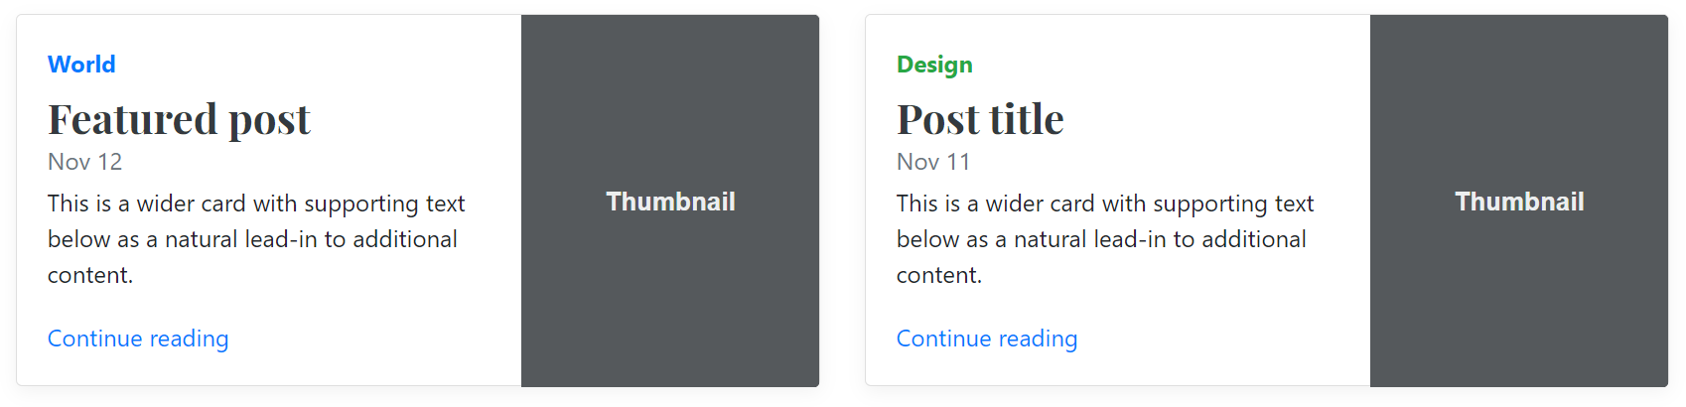

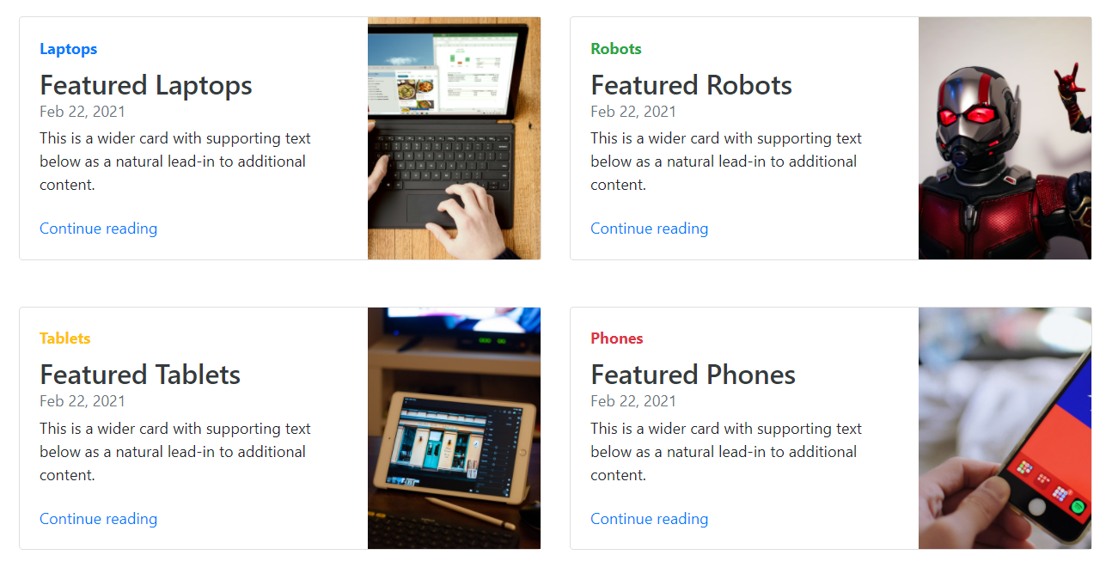

Step 10: Check how your site will look into laptop, iphone, tablet, etc. For that you right click on your page, select inspect option, select any device from responsive option.

Step 11: Add footer to your site after cards. Use code in footer code file to add footer. The code of footer is also available in a file.

Step 12: Create about.html file. Copy whole code of index.html and paste it in about.html file. Delete carousel code, cards code from the about.html file. The updated about.html file should contain only the initial code, navbar code, and footer code. The file should look like “step 12-initial about file.txt”.

Step 13: Choose proper template for about page. For instance, go to bootstrap, examples, carousel, use “First featurette heading. It’ll blow your mind.” For about.html page.

Step 14: Using inspect get the code of following row of the template and paste it in your about.html file using container [div.container] before the footer or after the navbar. After adding the code, you can see that your text is not coming at center both vertically and horizontally. Therefore, to make your text aligned center vertically and horizontally, use flex box. For that please replace the the existing code line {<div class="row featurette">} with this code {<div class="row featurette d-flex justify-content-center align-items-center">}. Further, you can see there is no gap between the navbar and the newly added row. Thus, to add row, use my-4 with main container. For that replace this line {<div class="container">} with this code {<div class="container my-4">}.

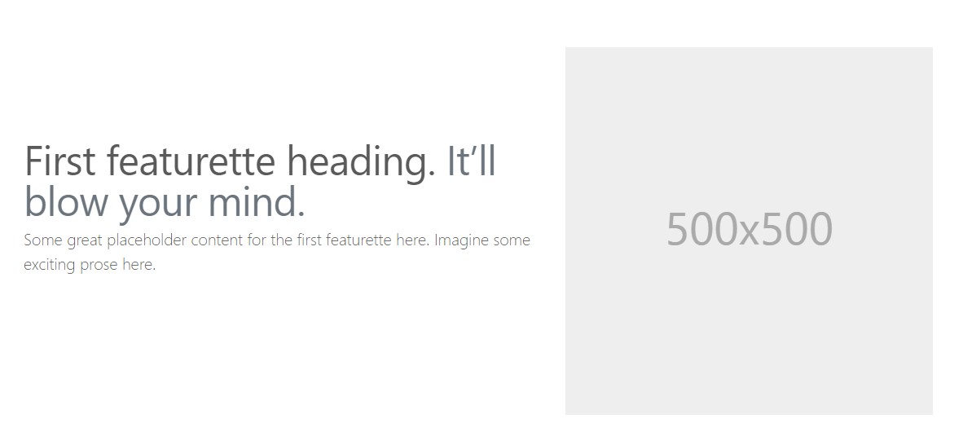

Step 15: Replicate 2 times same row by copying and pasting the code. Now we have three rows. We need to change the direction of image and text for second row. For that, change the third line of code in the row {<div class="col-md-7">} to this {<div class="col-md-7 order-md-2">}. In addition, change the 7th line of code {<div class="col-md-5">} to this line {<div class="col-md-5 order-md-1">}. Finally, your three rows should look like below.

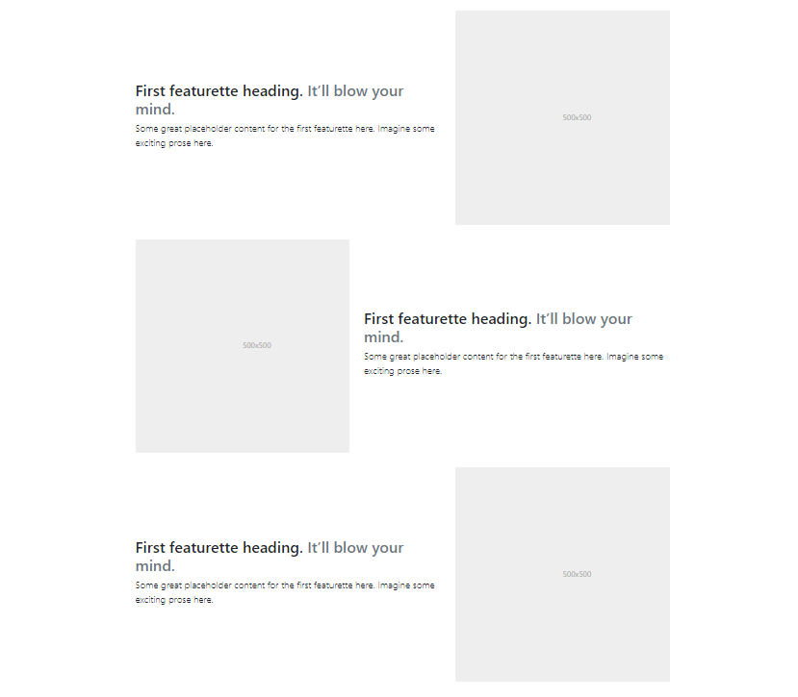

Step 16: To add pictures remove, SVG tag from each of three row and replace with following code.

<img class="img-fluid" src="about-1.jpg" alt="">

Step 17: Our about page is now completed. However, if you notice one thing that when we click about page, it is running but not showing active. Still Home is active. Hence, to achieve this, in about page, use active class in <li> tag in navbar. To do this, go to about.html file, navbar section, in home change this {<li class="nav-item active">} as {<li class="nav-item">}. Moreover, change this {<li class="nav-item">} in about section to :{ <li class="nav-item active">}.

The whole about file code is available in a file.

Step 17: Now create a new html file named ‘contact.html’. Copy paste the code from about.html and paste it into newly created contact.html file. Delete the rows but retain the navbar, footer, and head code. Just add following code between navbar and footer tags.

<div class="container my-4">

<h2>Contact Us</h2>

</div>

Step 18: NO, from bootstrap site, docs, components, forms, copy any form and paste it in contact.html file after contact us heading.

Step 19: On click contact us make it active by changing this line {<li class="nav-item">} in Navbar to this line {<li class="nav-item active">}.

Step 20: Add form to contact us page after heading of contact us. Add code ‘form code.txt’ inside div of h2 for form creation. After adding this form, your contact us page should look like following.

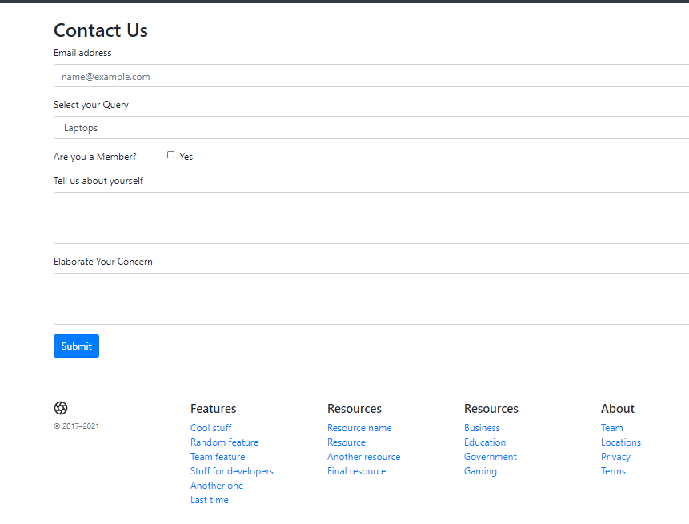

Step 21: Now, we need to add modal for login and sign up buttons on index.html page. For that go to components and use the code of any modal. Paste the code of modal two times after navbar code. One for Login and one for Sign Up buttons.

Step 22: In both codes, change example word with ‘login’ or ‘signup’. Update sign up and Login in button code by using the following code.

<button class="btn btn-danger" data-toggle="modal" data-target="#loginModal">Login</button>

<button class="btn btn-danger" data-toggle="modal" data-target="#signupModal">SignUp</button>

And remove the following code after sign up and login buttons and before login modal.

<!-- Button trigger modal -->

<button type="button" class="btn btn-primary" data-bs-toggle="modal" data-bs-target="#exampleModal">

Launch demo modal

</button>

Step 23: In Login modal body, use following form code.

<form>

<div class="form-group">

<label for="exampleInputEmail1">Email address</label>

<input type="email" class="form-control" id="exampleInputEmail1" aria-describedby="emailHelp">

<small id="emailHelp" class="form-text text-muted">We'll never share your email with anyone else.</small>

</div>

<div class="form-group">

<label for="exampleInputPassword1">Password</label>

<input type="password" class="form-control" id="exampleInputPassword1">

</div>

<div class="form-group form-check">

<input type="checkbox" class="form-check-input" id="exampleCheck1">

<label class="form-check-label" for="exampleCheck1">Check me out</label>

</div>

<button type="submit" class="btn btn-primary">Login</button>

</form>

Step 24: In Signup modal body, use following code.

<form>

<div class="form-group">

<label for="exampleInputEmail1">Email address</label>

<input type="email" class="form-control" id="exampleInputEmail1" aria-describedby="emailHelp">

<small id="emailHelp" class="form-text text-muted">We'll never share your email with anyone else.</small>

</div>

<div class="form-group">

<label for="exampleInputPassword1">Password</label>

<input type="password" class="form-control" id="exampleInputPassword1">

</div>

<div class="form-group">

<label for="cexampleInputPassword1">Confirm Password</label>

<input type="password" class="form-control" id="cexampleInputPassword1">

</div>

<button type="submit" class="btn btn-primary">Creat Account</button>

</form>

Step 24: The updated login and signup modal codes are given in ‘’logn-signup-modal-codes.txt’ file.

Step 25: Great! We made few pages of the website. Now its time to host it. So, Let’s host it on GitHub.

Step 26: Create GitHub account

Step 27: Login to GitHub account

Step 28: Create new repository by clicking + button and new repository, give name like ‘dealersinn’, give description, use ‘public’ and click on create repository.

Step 29: Now click on uploading the existing files. Drag and drop all the files here. Put ‘initial commit’ in commit box and then click commit.

Step 30: Go to Setting, In GitHub pages section, use source main, root and click save

Step 31: In theme, for instance, choose Cayman

Step 32: Now you should get the common URL for your website such as, <https://send2gm.github.io/dInn/>.

Step 33: Use this site to view it. If you found any issue. Goto repository, code, open index.html, about.html, and contact us.html. Change linking path from “/index.html” to /dInn/index.html in all file files and commit changes.

Step 34: If still issue in routing then manually, try {<https://send2gm.github.io/dInn/>index.html} OR {<https://send2gm.github.io/dInn/>about.html} OR {<https://send2gm.github.io/dInn/>contact.html}

Step 35: In some cases, commit will take time, so issue should resolve with time.